Members of the Galactic Dynamics Research Group
Postdoctoral Fellows and Doctoral Students

Current Members
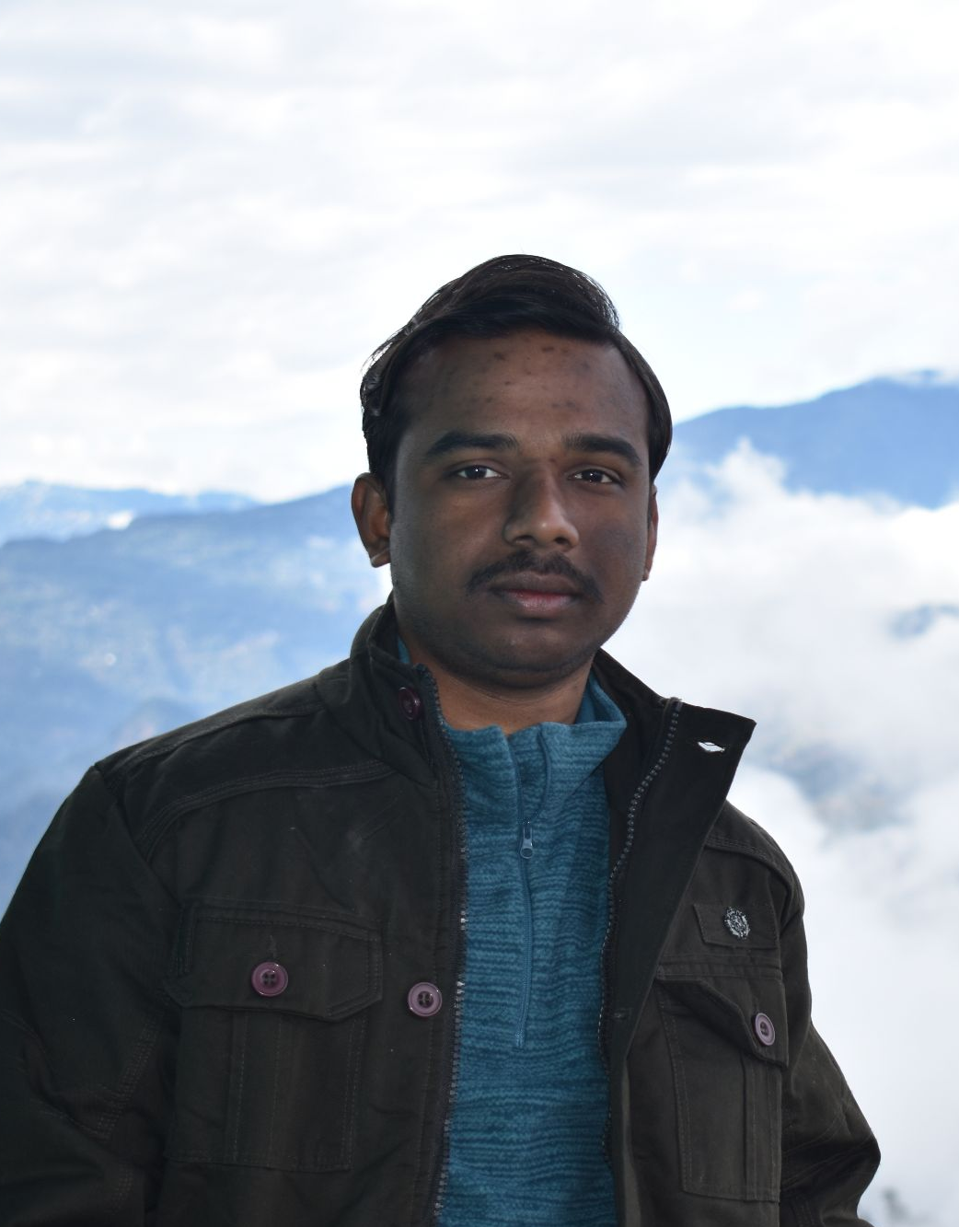

DEBASISH MONDAL (debasishmondal@labs.iisertirupati.ac.in)
Postdoctoral Fellow (CSIR Research Associate; Earlier SERB-CRG PDRF) (August 2023 - Present)
Ph.D. (Applied Mathematics), University of Calcutta (Thesis Submitted) Research Interest: Bar-driven Structure Formation in Disc Galaxies, Structure of Dark Matter Haloes, Order and Chaos in Dynamical Astronomy, Machine Learning aspects of Computational Astrophysics, Astrostatistics

Homepage: https://sites.google.com/view/debasishmondalastrophysics



ANAGHA A G ( anaghaag@students.iisertirupati.ac.in)
Ph.D student (January 2021 - present)
BS-MS (Physics), IISER THIRUVANANTHAPURAM
CSIR NET-JRF qualified
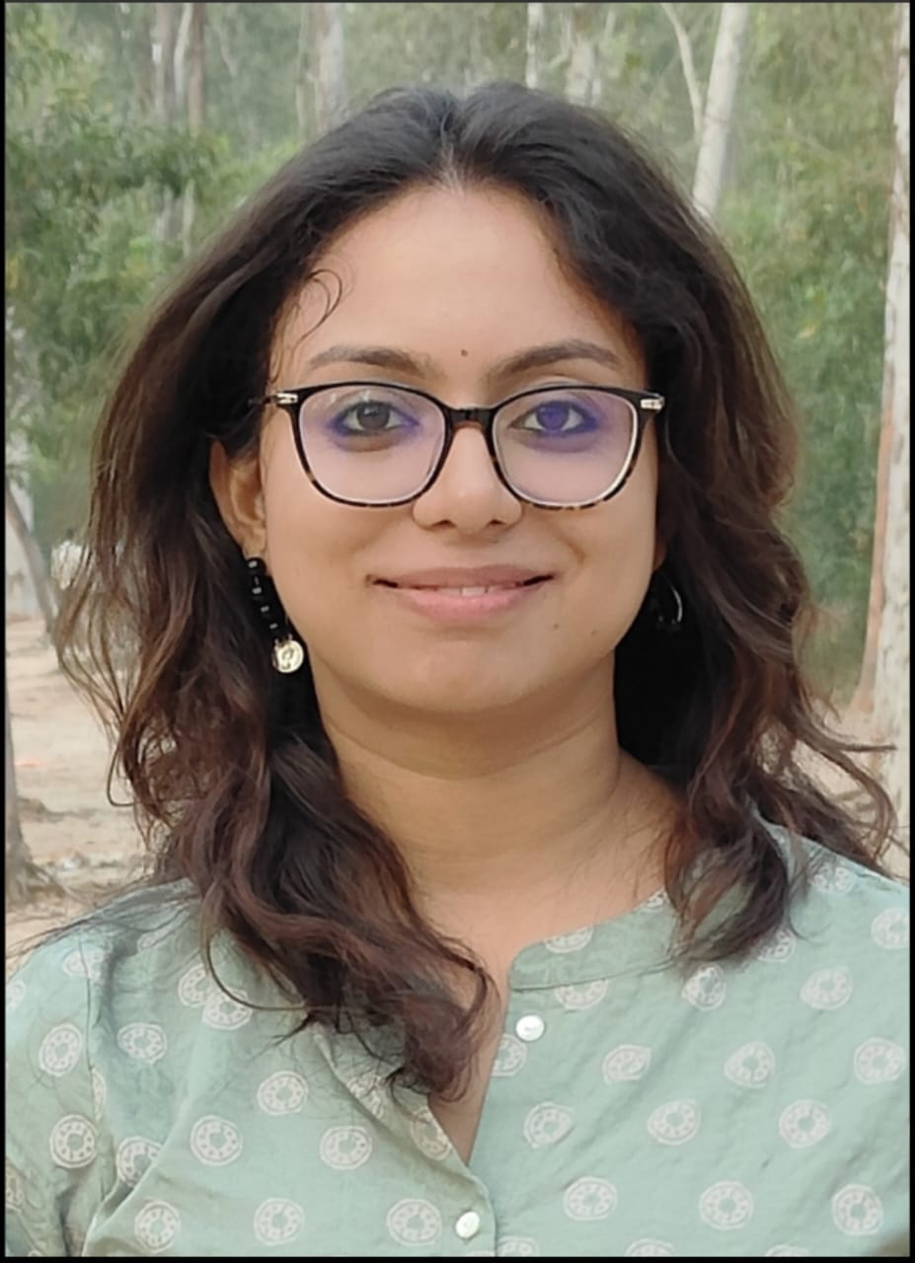
Research Interest: Dynamics of barred galaxies

NILANJANA NANDI (nilanjananandi@students.iisertirupati.ac.in)
Ph.D student (August 2021 - present) & Prime Minister’s Research Fellow
MSc (Physics), Calcutta University
CSIR NET-JRF qualified Research Interest: Dynamics of ultra-diffuse galaxies
Homepage: https://www.iisertirupati.ac.in/pmrf/nilanjana-nandi/

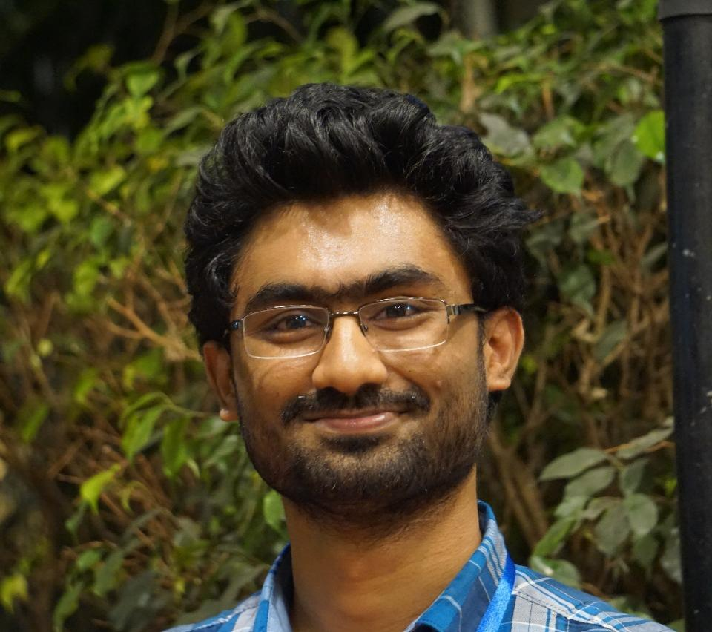

BIJU SAHA (biju_saha@students.iisertirupati.ac.in)
Ph.D student (August 2022 - present) & Prime Minister’s Research Fellow
MSc (Physics), Jawaharlal Nehru University
DST-INSPIRE Ph.D Fellowship awarded
Research Interest: Dynamics of lopsided galaxies
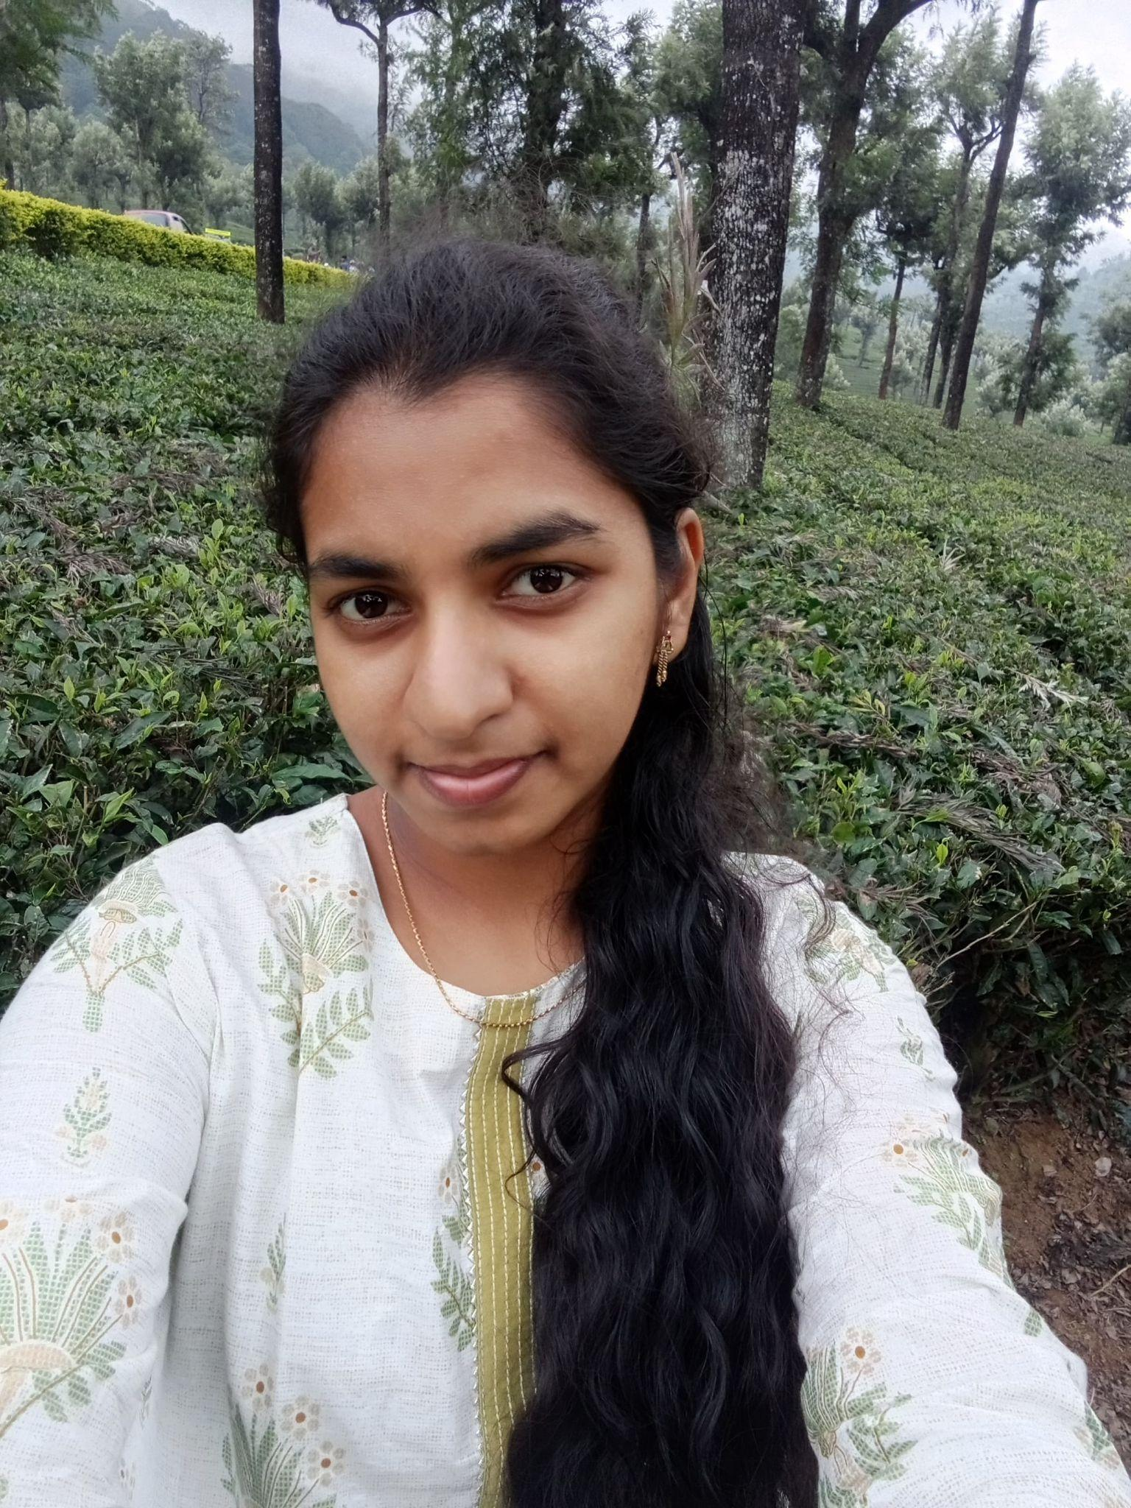
Homepage: https://www.iisertirupati.ac.in/pmrf/biju-saha/

J SARANYA (saranyajawaran@students.iisertirupati.ac.in)
Ph.D student (January 2023 - present)
MSc (Physics), Manipal Institute of Technology, Karnataka
Research Interest: Dynamics of warped galaxies
Past Members
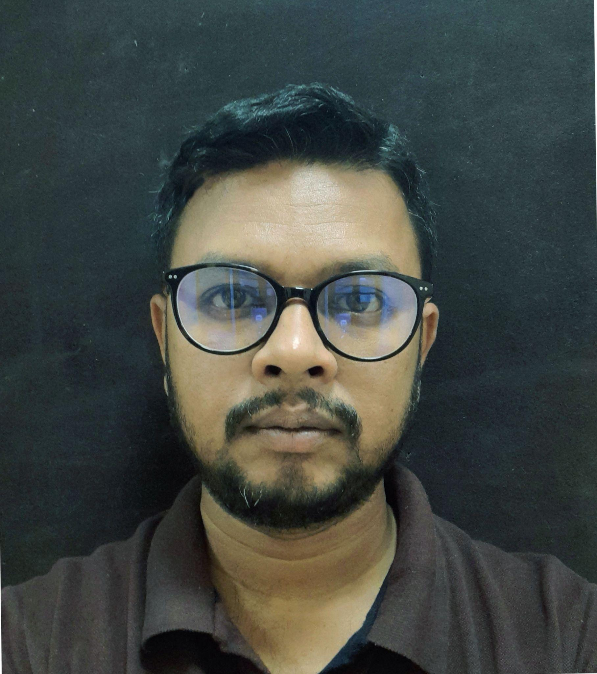
Dr. SUMAN SARKAR (suman2reach@gmail.com)
Former Postdoctoral Fellow (2021-2022)
Ph.D (Physics), Visva Bharati University
Research Interest: Large scale structures of the Universe, Galaxy formation and evolution, Information-theory, Machine learning.
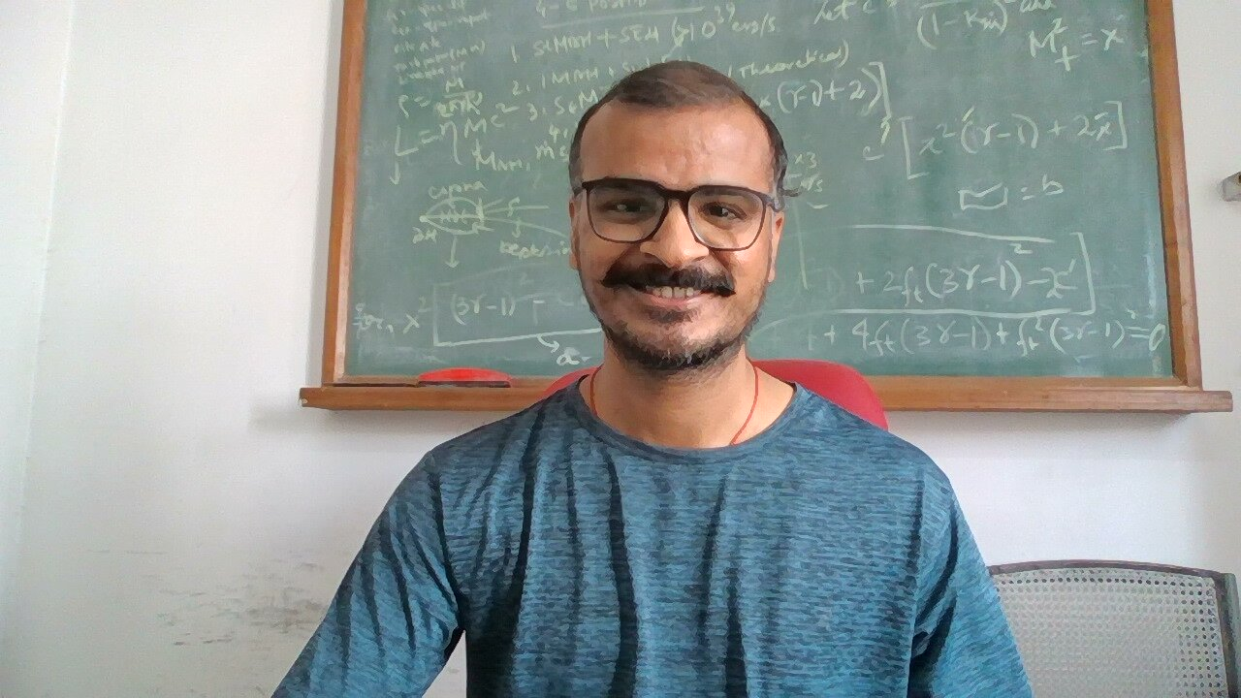
Currently a Faculty Member @ Biswa Bangla Biswabidyalay, Bolpur, West Bengal, India - 731204

Dr. K Aditya (kaditya@students.iisertirupati.ac.in)
Former PhD student (2017-2022)
Research Interest: Radio observation of superthin galaxies using the Giant Meterwave RadioTelescope (GMRT) and galactic dynamics.
Homepage: https://8dualityisreality8.github.io/Aditya/
Currently Postdoctoral Fellow @ Raman Research Institute, Bangalore
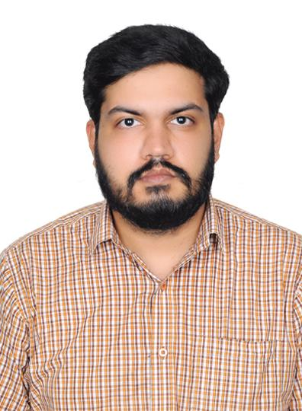
GANESH N (ganeshn@students.iisertirupati.ac.in)
Ph.D. student (August 2018 - 2024)
MSc (Physics), Christ University Bangalore
Research Interest: Dynamics of Low Surface Brightness galaxies
Currently an Aerodynamics Engineer @ Digantara Private Limited, Bangalore

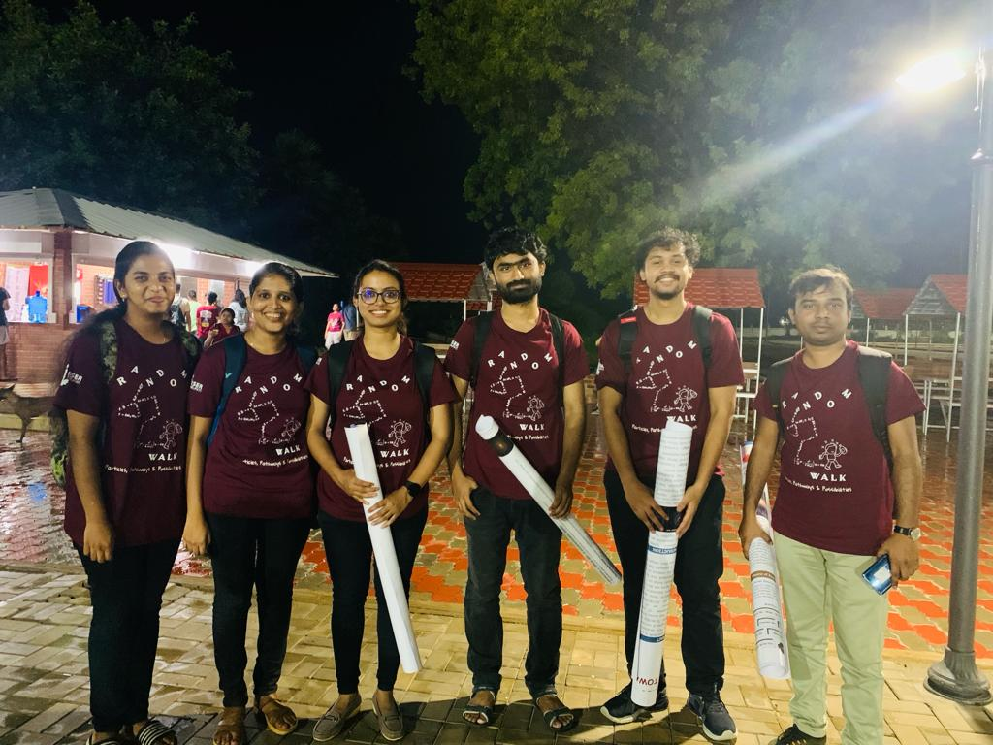
Physics Day @ IISER Tirupati, November 2023

