**Members of the Galactic Dynamics Research Group**

Postdoctoral Fellows and Doctoral Students

**Current Members**

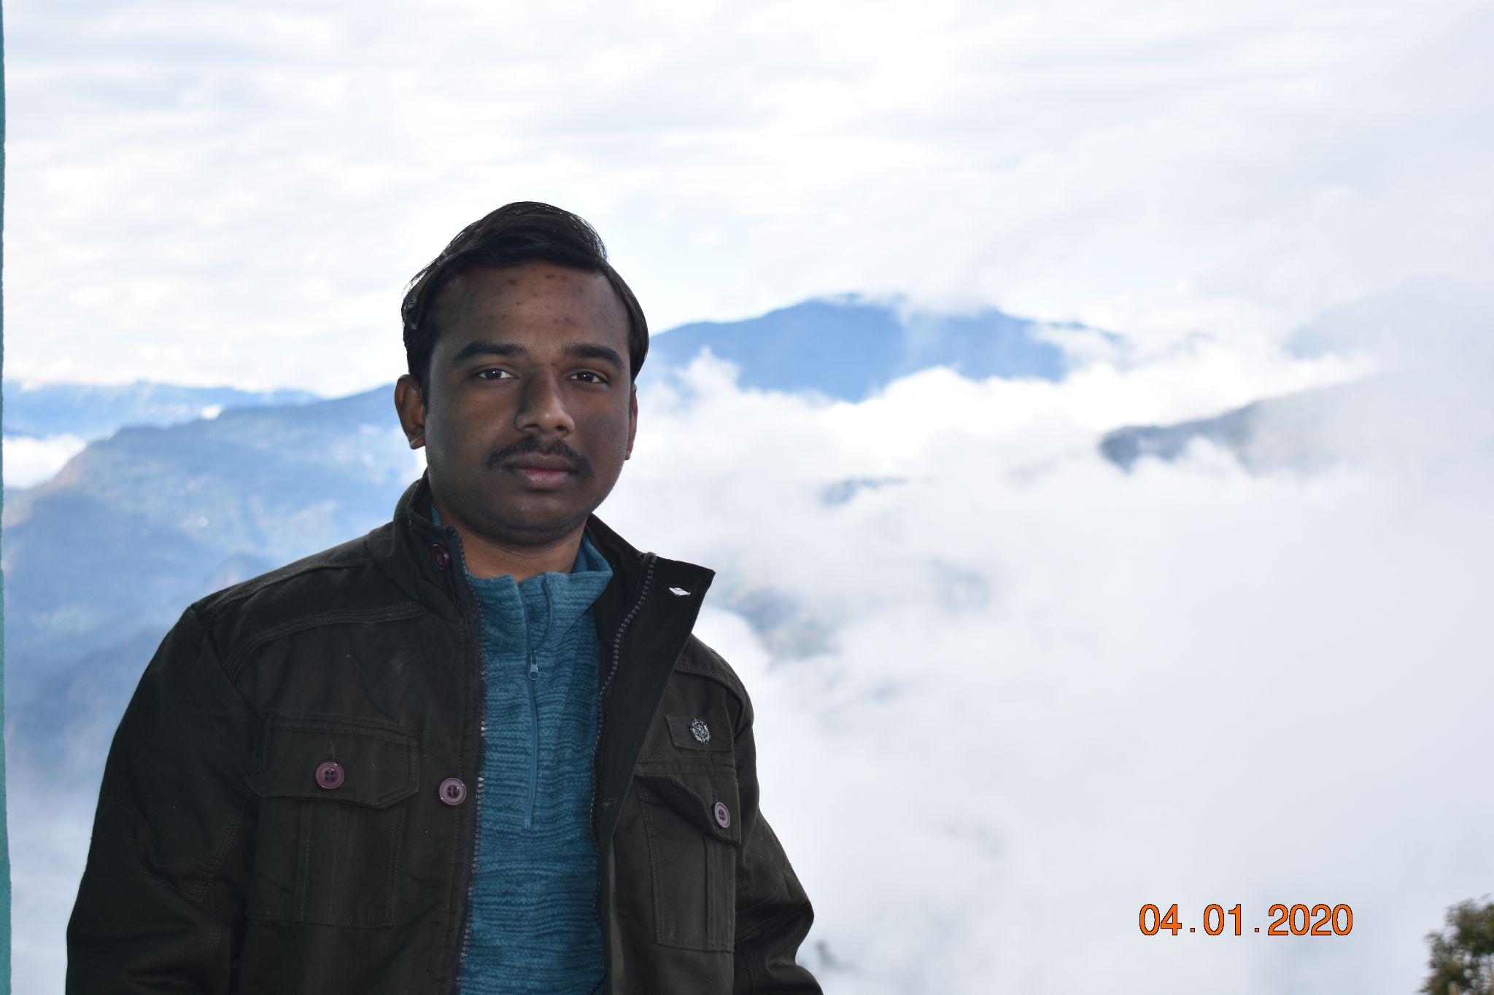

**DEBASISH MONDAL (**[debasishmondal@labs.iisertirupati.ac.in](mailto:debasishmondal@labs.iisertirupati.ac.in)**)**

Postdoctoral Fellow (SERB-CRG Project) (August 2023 - Present)

Ph.D. (Applied Mathematics), University of Calcutta (Thesis Submitted) *Research Interest:* Bar-driven Structure Formation in Disc Galaxies, Structure of Dark Matter Haloes, Order and Chaos in Dynamical Astronomy, Machine Learning aspects of Computational Astrophysics, Astrostatistics

**Homepage:** https://sites.google.com/view/debasishmondalastrophysics

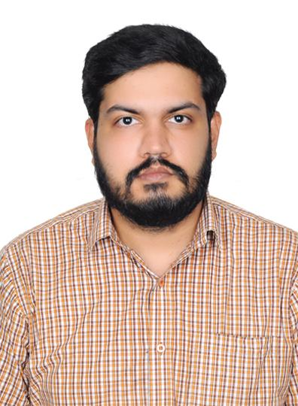

**GANESH N** ([ganeshn@students.iisertirupati.ac.in](mailto:ganeshn@students.iisertirupati.ac.in))

Ph.D. student (August 2018 - Present)

MSc (Physics), Christ University Bangalore

*Research Interest: Dynamics of Low Surface Brightness galaxies*



**ANAGHA A G** ( [anaghaag@students.iisertirupati.ac.in](mailto:anaghaag@students.iisertirupati.ac.in))

Ph.D student (January 2021 - present)

BS-MS (Physics), IISER THIRUVANANTHAPURAM

CSIR NET-JRF qualified

*Research Interest: Dynamics of barred galaxies* 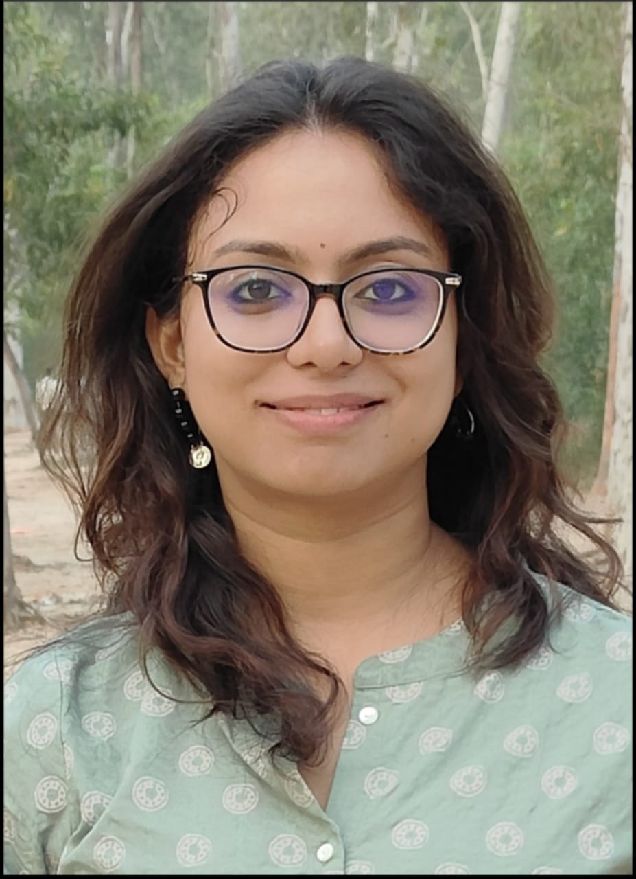

**NILANJANA NANDI** ([nilanjananandi@students.iisertirupati.ac.in](mailto:nilanjananandi@students.iisertirupati.ac.in))

Ph.D student (August 2021 - present) & Prime Minister’s Research Fellow

MSc (Physics), Calcutta University

CSIR NET-JRF qualified

*Research Interest: Dynamics of ultra-diffuse galaxies*

**Homepage:** https://www.iisertirupati.ac.in/pmrf/nilanjana-nandi/

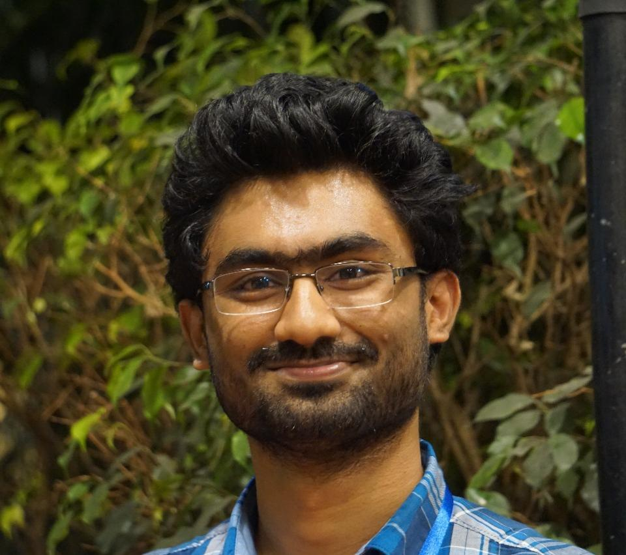

**BIJU SAHA** ([biju_saha@students.iisertirupati.ac.in](mailto:biju_saha@students.iisertirupati.ac.in))

Ph.D student (August 2022 - present) & Prime Minister’s Research Fellow

MSc (Physics), Jawaharlal Nehru University

DST-INSPIRE Ph.D Fellowship awarded

*Research Interest: Dynamics of lopsided galaxies*

**Homepage:** https://www.iisertirupati.ac.in/pmrf/biju-saha/

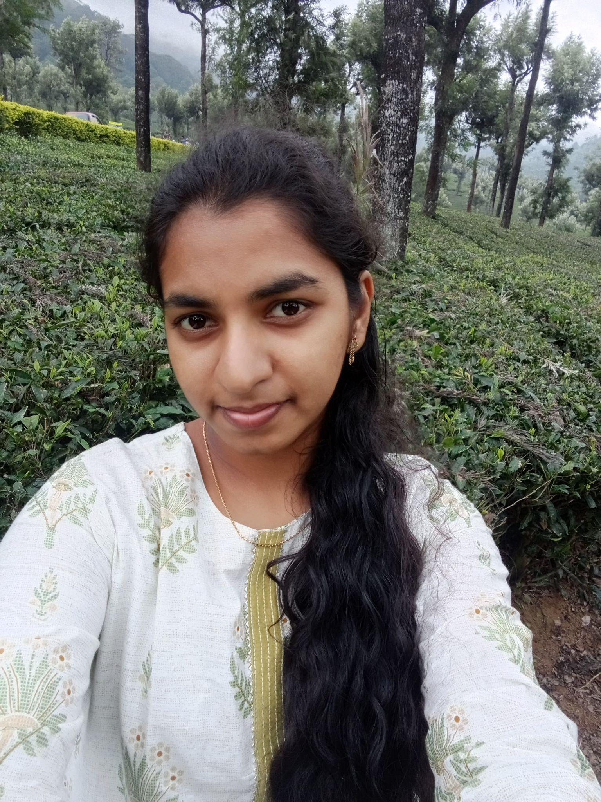

**J SARANYA** ([saranyajawaran@students.iisertirupati.ac.in](mailto:saranyajawaran@students.iisertirupati.ac.in))

Ph.D student (January 2023 - present)

MSc (Physics), Manipal Institute of Technology, Karnataka

*Research Interest: Dynamics of warped galaxies*

**Past Members**

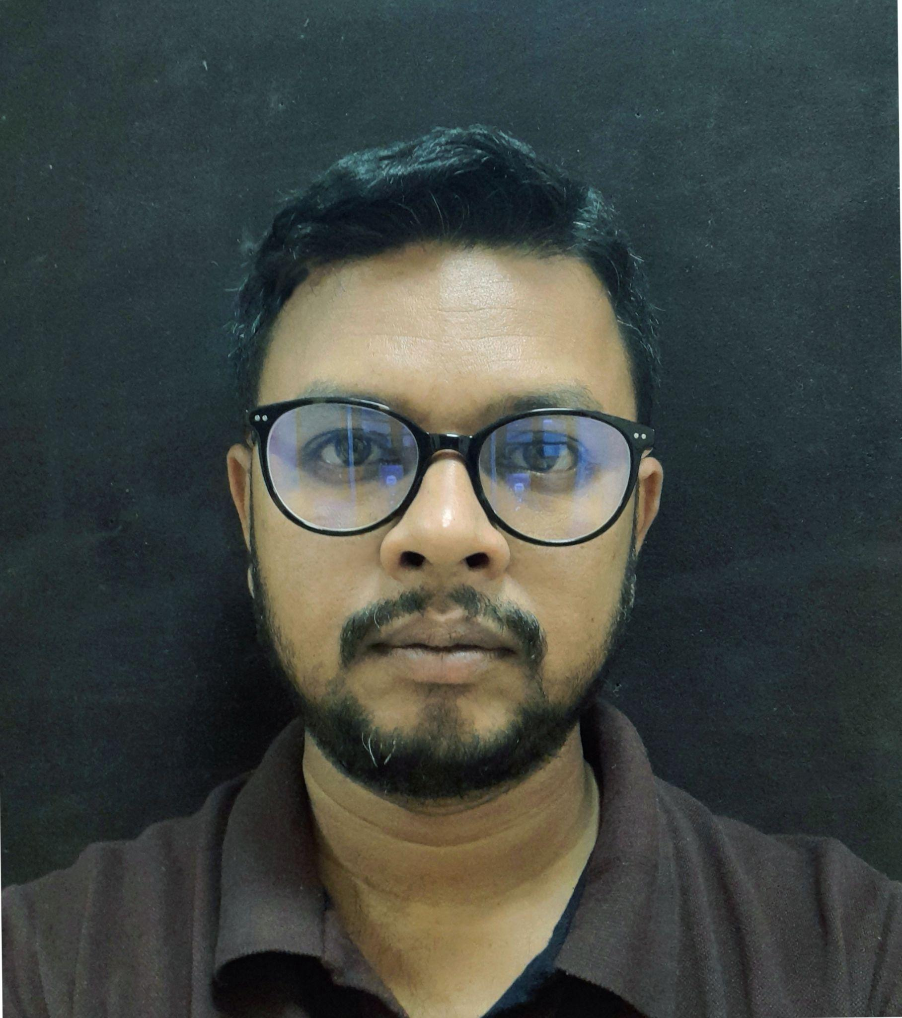

**Dr. SUMAN SARKAR (**[suman2reach@gmail.com](mailto:suman2reach@gmail.com)**)**

Former Postdoctoral Fellow (2021-2022)

Currently National Postdoctoral Fellow @ Department of Physics, IIT Kahargpur

Ph.D (Physics), Visva Bharati University

*Research Interest: Large scale structures of the Universe, Galaxy formation and evolution, Information-theory, Machine learning.*

**Dr. K Aditya (**kaditya@students.iisertirupati.ac.in**)**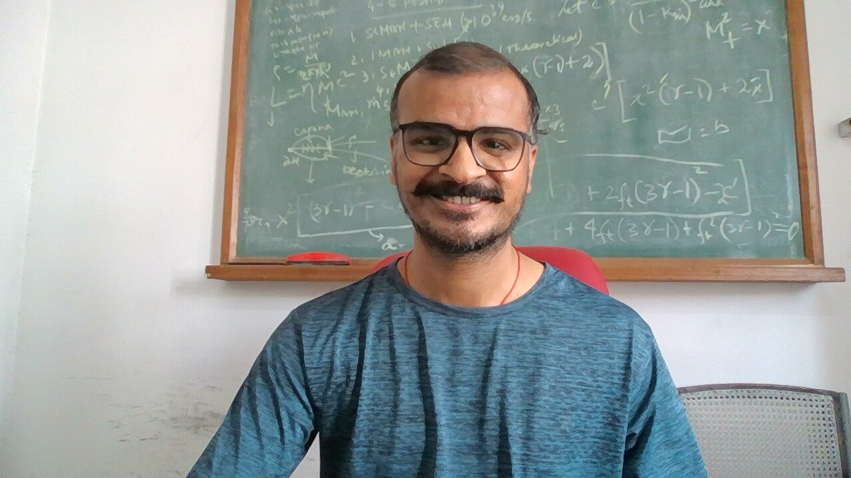

Former PhD student (2017-2022)

Currently Postdoctoral Fellow @ Indian Institute of Astrophysics, Bangalore

*Research Interest: Radio observation of superthin galaxies using the Giant Meterwave RadioTelescope (GMRT) and galactic dynamics.*

**Homepage:** https://8dualityisreality8.github.io/Aditya/

**Physics Day @ IISER Tirupati, November 2023**

