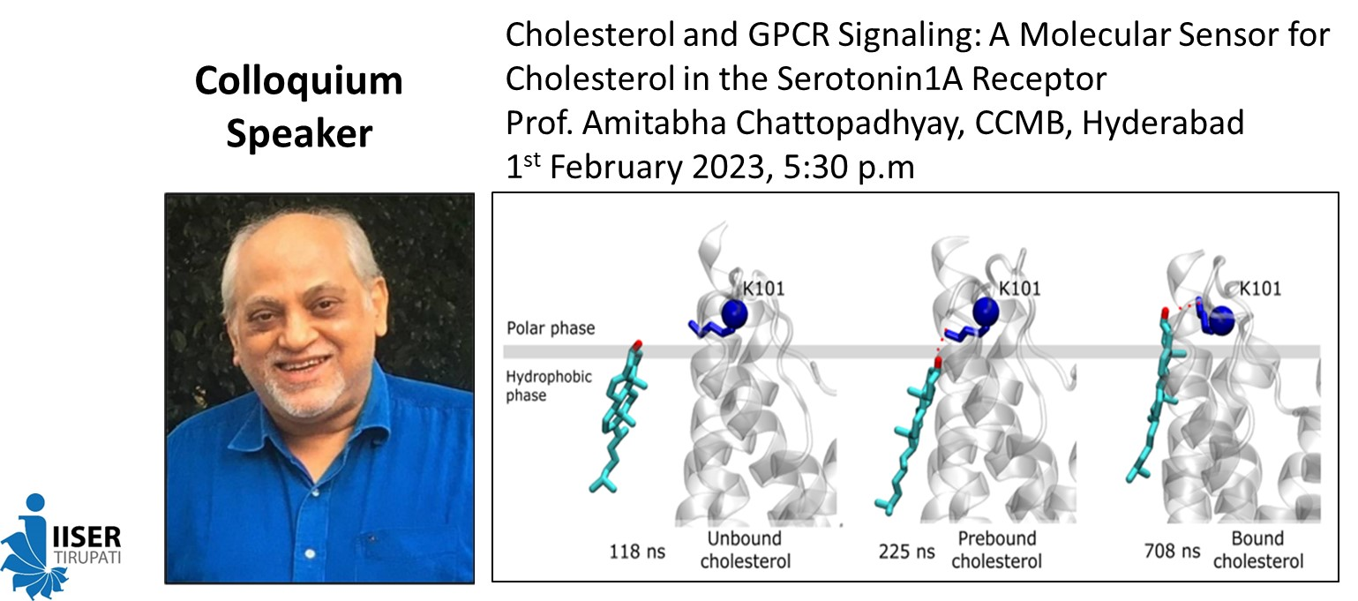

**Abstract:** G protein-coupled receptors (GPCRs) are the largest class of molecules involved in signal transduction across membranes, and represent major drug targets in all clinical areas.  The serotonin1A receptor is an important neurotransmitter receptor of the GPCR superfamily and is implicated in the generation and modulation of various cognitive, behavioral and developmental functions.  In our earlier work, we demonstrated that membrane cholesterol is necessary for ligand binding, G-protein coupling and signaling of serotonin1A receptors.  In the overall context of high-resolution structures of GPCRs showing bound cholesterol molecules, we previously reported the presence of cholesterol recognition/interaction amino acid consensus (CRAC) motifs in the serotonin1A receptor.  In our recent work, we explored the molecular basis of cholesterol sensitivity exhibited by the serotonin1A receptor by generating mutants of key residues in CRAC motifs in transmembrane helices (TM) 2 and 5 of the receptor.  Our results show that a lysine residue (K101) in one of the CRAC motifs is crucial for sensing altered membrane cholesterol levels.  These observations are further supported from all-atom molecular dynamics simulations which reveal a tightly bound cholesterol molecule between TM1 and TM2 by establishing polar contacts with K101 that leads to stabilization of extracellular loop 1 (ECL1).  Interestingly, the position of this cholesterol molecule is almost identical to a co-crystallized cholesterol molecule in the recently reported high-resolution cryo-EM structure of the serotonin1A receptor, thereby strongly validating the molecular mechanism for cholesterol sensitivity of the serotonin1A receptor proposed by us.  These results constitute one of the first reports comprehensively demonstrating that cholesterol sensitivity could be knocked out by a single point mutation in a specific cholesterol binding site. We envision that progress in deciphering molecular details of the nature of GPCR-cholesterol interaction would lead to better insight into our overall understanding of GPCR function in health and disease.

**About the speaker:**

Prof. Amitabha Chattopadhyay is a global leader in membrane and receptor biology and biophysics and is a CSIR Bhatnagar Fellow at the Centre for Cellular and Molecular Biology (CCMB) in Hyderabad (India), and Professor and Founding Dean of Biological Sciences at the Academy of Scientific and Innovative Research. Prof. Chattopadhyay received B.Sc. with Honors in Chemistry from St. Xavier’s College (Calcutta) and M.Sc. in Chemistry from IIT Kanpur. He obtained his Ph.D. from the State University of New York (SUNY) at Stony Brook, and was a Postdoctoral Fellow at the University of California at Davis, prior to joining CCMB. Prof. Chattopadhyay’s work is focused on monitoring organization, dynamics and function of biological membranes in healthy and diseased conditions. His group has developed and applied novel, innovative and sensitive techniques based on fluorescence spectroscopy for monitoring solvent relaxation in membranes, membrane-mimetic media, and proteins. These insightful studies have led to a better understanding of the dynamics of hydration in membranes and proteins. Prof. Chattopadhyay’s pioneering contributions in membrane and receptor biology and biophysics have been recognized by several awards and prizes. These include The World Academy of Sciences (TWAS) Prize, Shanti Swarup Bhatnagar Award, Ranbaxy Research Award, Prof. G.N. Ramachandran Gold Medal, SERB Distinguished Fellowship, Prof. G.N. Ramachandran 60th Birthday Medal and J.C. Bose Fellowship. He is an elected Fellow of The World Academy of Sciences, Royal Society of Biology, Royal Society of Chemistry, and all the Indian Academies of Science. Prof. Chattopadhyay has served on the editorial boards of a large number of journals that include Biophysical Journal, The Journal of Physical Chemistry, Biophysical Reviews, Journal of Neurochemistry, BBA-Biomembranes, Journal of Membrane Biology, FEBS Letters, IUBMB Life and ACS Chemical Neuroscience.